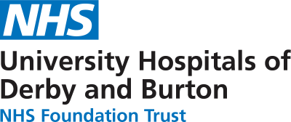

**LKS Newsletter**

Volume 2 - April 2024

**CLINICAL LIBRARIAN (CL) SERVICE**

***Could we help you?***

Our Clinical Librarians work in partnership with clinical and non-clinical staff to provide information to support patient care, service delivery, and quality improvement. They ensure that questions arising in clinical encounters are answered on the basis of good, sound evidence. They also contribute to the development of clinical guidelines, policies and procedures and provide a variety of training opportunities.

The two articles below illustrate how we can contribute to your work:

**CLINICAL LIBRARIAN CHLOE RECOGNISED FOR VITAL WORK SUPPORTING RESEARCH AND QUALITY IMPROVEMENT IN A&E**

Chloe Turner has been recognised by Dr Andrew Tabner, Emergency Medicine Consultant, for her ongoing support to colleagues in Royal Derby Hospital's Emergency Department (ED). Chloe's efforts include evidence searching and aiding colleagues and students across the Trust with training.

Dr Arne Rose, Deputy Medical Director and Consultant Emergency Medicine Consultant, presented Chloe with the Making a Difference Award, said: "the library service plays a vital role in delivery of the right care to our patients, and supports our future workforce through research and training".

"It is great to hear that Chloe's behind the scenes work is getting recognised by her clinical colleagues, and that her work is having such a positive impact at the Trust".

More information on this award can be found on Net-I ([click here to open](https://neti.uhdb.nhs.uk/homepage-right-side-top/clinical-librarian-chloe-recognised-for-vital-work-supporting-research-and-quality-improvement-in-ae-17434)).

**CLINICAL LIBRARIAN SERVICE USED BY THE PSIRF TEAM**

Literature searches (a systematic and thorough search of the published literature) can be requested, by any member of Trust staff, from the CLs and upon completion, results will be emailed. [Click here to request](https://www.uhdblibrary.co.uk/literature-search)

Lucy Nankivell, Head of Clinical Improvement and Transformation, leading The Patient Safety Incident Response Framework, used this service recently when we were approached to help understand whether there are links between protected characteristics, and a 'do not resuscitate' (DNACPR) decision.

Lucy outlines that "It is important to understand literature within the Library and Knowledge service, so that we can identify whether there are any high-risk groups which are affected by resuscitation.The Library and Knowledge team discovered a lot of research around protections and responsibilities for people with reduced capacity for decision-making in advanced care planning, related to dementia, learning disabilities, and mental health…

Exploring the evidence allows us to better understand the risk, and the barriers that these groups may face. This enables us to be intentionally inclusive for those at greater risk of suffering futile and inappropriate resuscitation."

A more in depth discussion of their results and how this learning helped can be found on their QSL thread ([click here to open](https://neti.uhdb.nhs.uk/quality-and-safety-learning-headlines/understanding-health-inequalities-and-their-impact-on-do-not-resuscitate-dnacpr-decisions-17296)).

**QUALITY, SAFETY AND LEARNING PORTAL - THE LKS 'LEARNING FROM EVIDENCE' THREAD LAUNCH.**

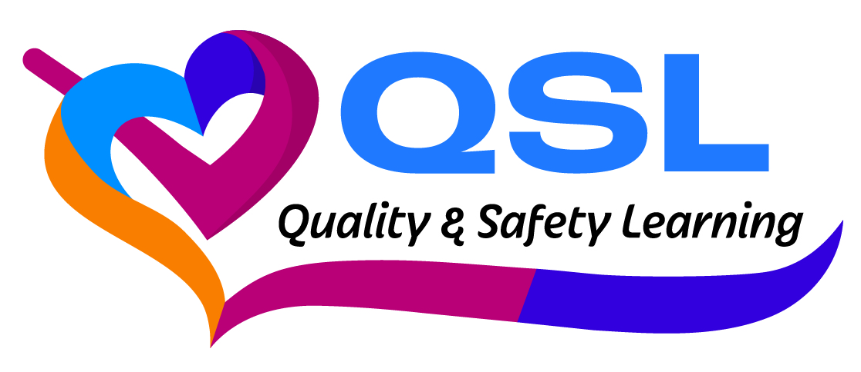

We are excited to announce that we are part of the Phase 2 Early Adopters on the Trust's new QSL Portal.

QSL is UHDB's central hub of shared clinical learning, and our 'Learning from Evidence' thread will provide regular updates and illustrations on our many and varied resources and services that can be used to support your clinical (and non-clinical) practice.

A contributor to our new thread,Simon Cole, is an ENT Higher Specialty trainee ST7 and BMJ Best Practice Clinical Champion and uses one of our resources, BMJ Best Practice, regularly.

He says he uses it to " look up conditions which may overlap with my specialty specific areas such as respiratory and dermatology. I also use it to rapidly understand any other rarer medical problems which my patients have which I know less about."

So, with regard to the impact that it can have on his service, he says "It allows better work up of any comorbidities in our inpatients prior to seeking advice from another specialty."

Keep an eye on the QSL Portal ([click here to open](https://neti.uhdb.nhs.uk/qsl)) to find out how else the LKS can support the quality, safety and learning in your department.